STANDARD FORMAT OF “LEHENGA DESCRIPTION”


For Online Selling Products
Design Name: SRIVALLI-A
Product Colours NO.: A3
. 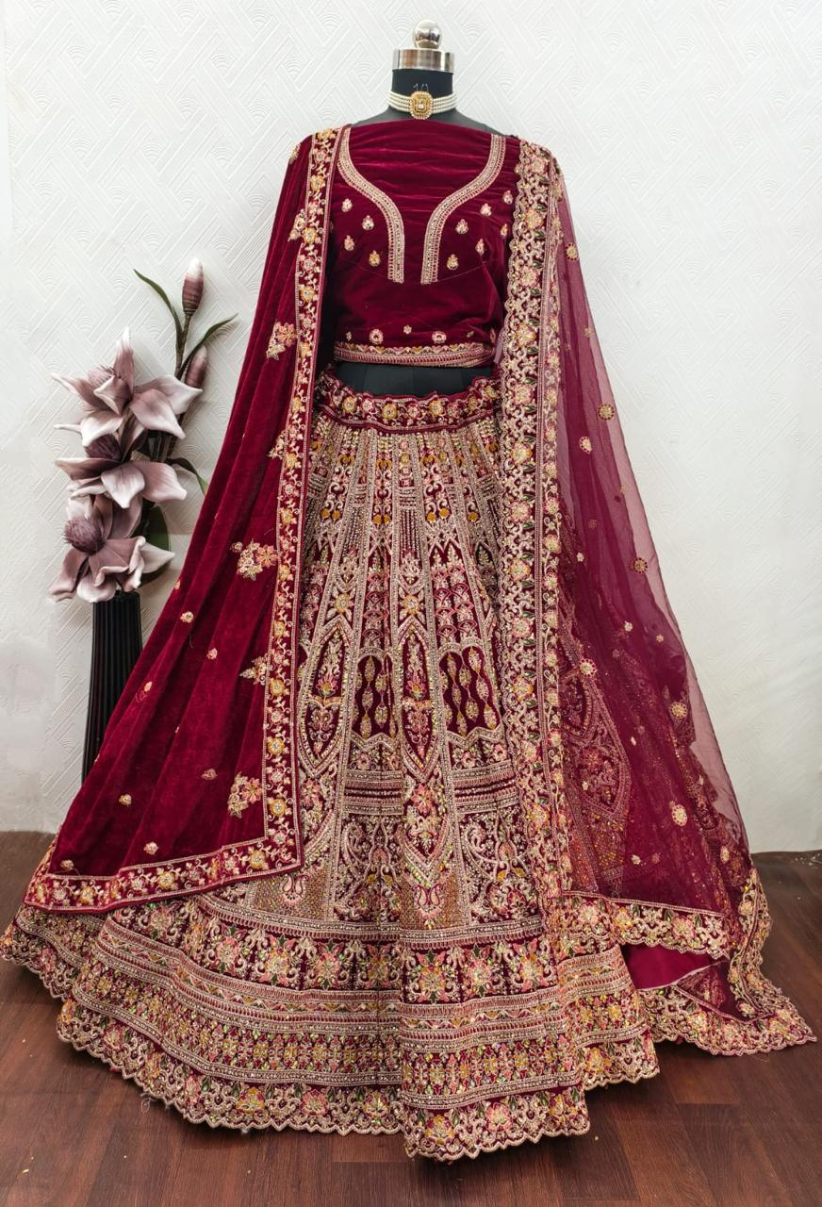
Particulars | Details
Lehenga Fabric | Premium Velvet
Blouse Fabric | Premium Velvet
Dupatta Fabric | - Net Dupatta  &  - Velvet Dupatta
Work Type | Jari & Embroidery Work
Colour | Bridal Maroon
Pattern | Bridal Designer Lehenga
Stitching Type | Semi-Stitched (Can be customized up to 44")
Occasion | Wedding
Fit Type | Regular Fit
Care Instructions | Dry Clean Only
Package Contents | 1 Lehenga, 1 Blouse Piece, 2 Dupatta

KEY HIGHLIGHTS
- Premium Velvet fabric used in both lehenga and blouse for a rich and luxurious finish
- Beautifully detailed with intricate zari and embroidery work enhancing bridal elegance
- Comes with a dual dupatta set – one soft net dupatta and one rich velvet dupatta
- Elegant Bridal Maroon colour that gives a royal and traditional wedding look
- Designed as a Bridal Designer Lehenga, perfect for weddings and grand occasions
- Semi-stitched pattern allows easy customization up to size 44 inches
- Regular fit ensures comfort along with a graceful silhouette
- Ideal choice for weddings, bridal wear, and special ceremonial functions
- Requires dry clean only to maintain fabric quality and embroidery work

